Python Mini Project

This mini project analyses data from the public Wind Integration National Dataset. This dataset was prepared by NREL. NREL is a national laboratory of the U.S. Department of Energy Office of Energy Efficiency & Renewable Energy

1. Download the datafile:

wtk_site_metadata.csv

for this mini project from this web page:

<https://data.nrel.gov/submissions/54>

2. Write a short program using **pandas** to display:

a) the first 5 rows

b) a random sample of 5 rows

c) the last 5 rows

3. Now write a program that plots the location (latitude and longitude) of each row that pertains to Texas. Your plot should look like the screenshot below:

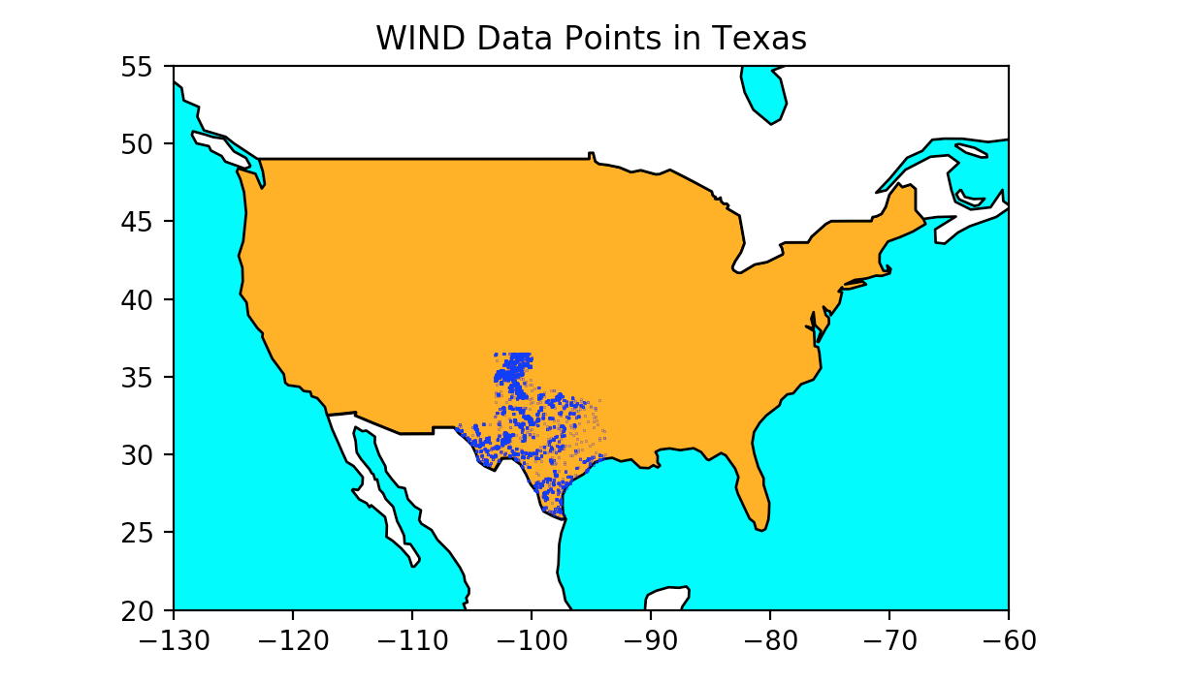

You will need to import **geopandas** to obtain a low resolution world map. You can then extract the outlines of Canada, USA and Mexico to create the background for the map.

Now use a combination of **pandas**, **geopandas** and **matplotlib** to plot the locations of each row that relates to Texas.

4. Use **pandas** to print a list of all the states with datapoints in the datafile. You should find that there are 49 states with datapoints in the set.

5. Use **pandas** to print out a table of the centroids of each state in the above list. You will need to aggregate the longitude and latitude values for each row in a given state and take the mean. Your ouput should look like:

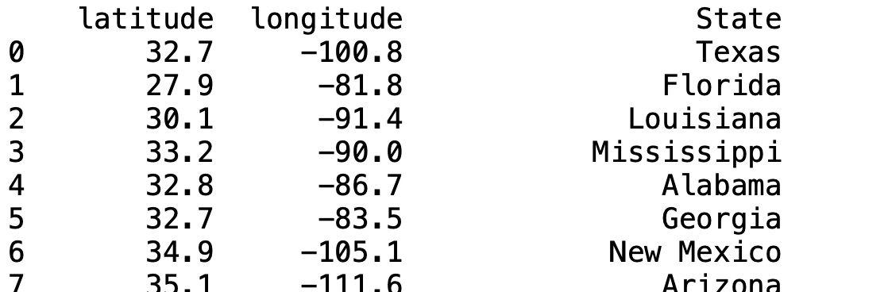

6. Given the information you have just calculated you should now be able to construct the following plot:

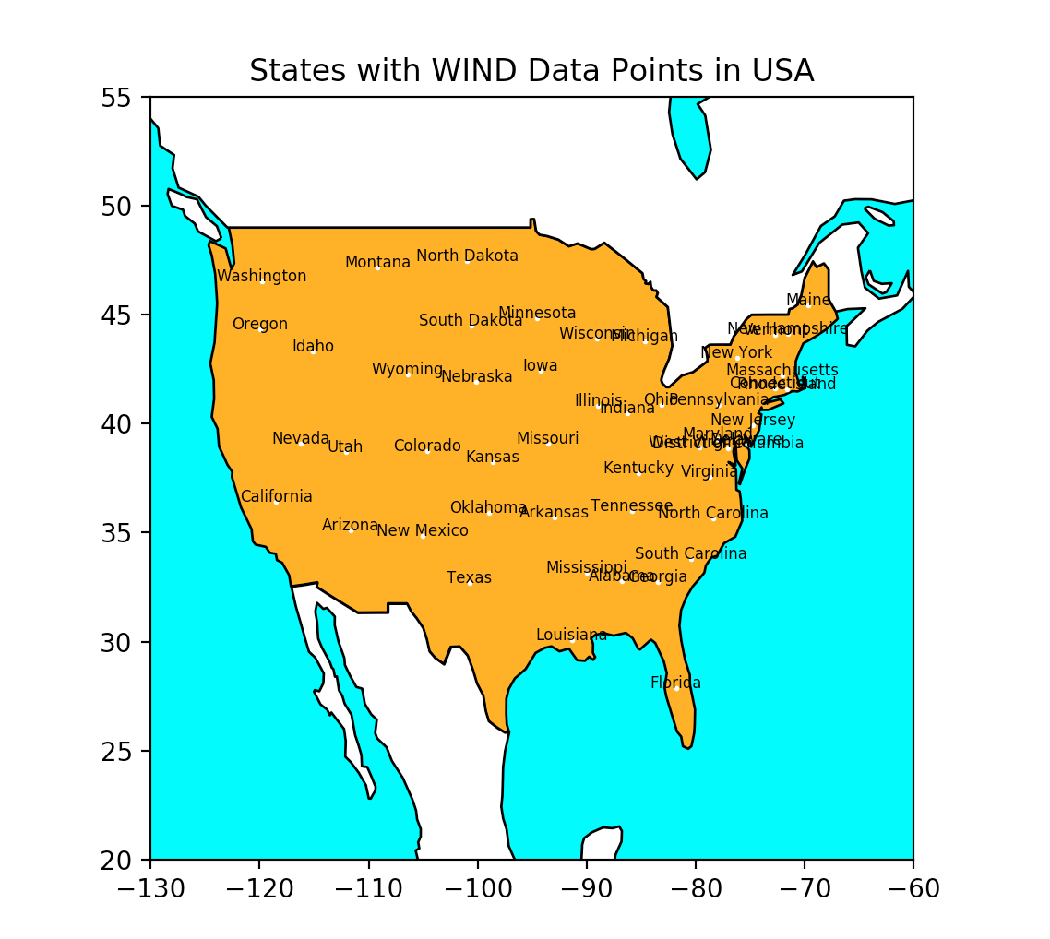

7. Finally, use **pandas** to plot a bar chart of "Average Wind Speed" for each state:

